

**Noel Pearson seeks a meeting with ABC**

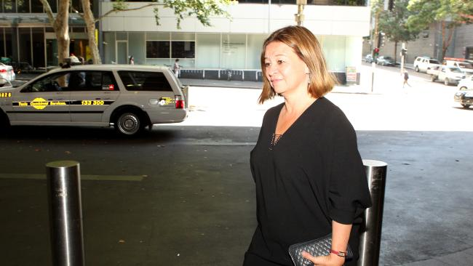

ABC chief executive Michelle Guthrie. Picture: Hollie Adams

* The Australian
* November 28, 2016
* [PAUL CLEARY](http://www.theaustralian.com.au/author/Paul+Cleary)

http://pixel.tcog.cp1.news.com.au/track/component/author/a08d9264e3d273919bd17ac796225521/?esi=true&t_product=the-australian&t_template=s3/austemp-article_common/vertical/author/widget&td_bio=false

Indigenous leader Noel Pearson has requested a special meeting with ABC managing director Michelle Guthrie to outline his concerns about the national broadcaster’s coverage of Aboriginal issues.

A spokesman for Ms Guthrie said the ABC had received the request on Friday afternoon and at this stage had no comment to make.

Asked if the ABC was reviewing its coverage in the wake of Mr Pearson’s statement the broadcaster focused on “misery and bleeding tragedy”, the spokesman told The Australian: “The ABC reviews all of its content on a regular basis, including indigenous coverage.”

In a speech over the weekend to the National Ethnic and Multicultural Broadcasters Council’s annual conference, Ms Guthrie hit back at Mr Pearson when she said the ABC had a legitimate role to “highlight those problems and inform the wider community about them. I see absolutely no reason for the ABC to apologise for this very important work.”

Ms Guthrie also recited from a long list of “ambitious” indigenous programs that ran on ABC TV this year, and which involved indigenous actors, writers and producers.

Supporting Mr Pearson’s comments, the Prime Minister’s indigenous Advisory Council chair Nyunggai Warren Mundine said the ABC’s news and current affairs division had ignored economic development stories and was “trying to keep Aboriginal people in a museum”.

Instead, “getting the government to provide heaps and heaps of money” was the way the ABC news and current affairs addressed most indigenous problems, he told The Australian. Mr Mundine limited his criticism to ABC news and current affairs.

He said much of the ABC’s news and current affairs coverage ignored the fact that “the vast majority of Aboriginal people have got on with their lives”. He pointed out that more than 30,000 Aboriginal people are currently attending university, up from a handful during his generation.

“Aboriginal people are keeping up in home ownership. For the university educated, there’s no gap,” he said.

However, he welcomed the appointment of Stan Grant as indigenous editor at the ABC, adding: “I hope Stan Grant’s appointment will turn this around.”

Ms Guthrie also addressed a criticism that the ABC had to do better in attracting staff who reflected Australia’s ethnic diversity, and in programming as well.

She said there was a “disconnect” between the people seen on TV screens and the faces in the street.

“Any visitor who switches on a television notes that the faces on screen are remarkably different to those they see as they walk the streets,” she said.

But she revealed that the TV division had committed to lifting the share of content makers from non-English speaking backgrounds from 9 per cent to 12 per cent within the next six months.

Ms Guthrie said the current level was clearly unacceptable when more than 20 per cent of Australians spoke a language other than English at home.

“Given that 20 per cent of all Australians speak a language other than English at home, it is not ideal that just over 9 per cent of television content makers identify as NESB. This problem is apparent in the wider TV industry, but clearly shows the ground we need to make up,” she told the conference.

But the current 9 per cent figure seems to be an improvement on the level in 2015, which had dropped almost 1 percentage point to 7.4 per cent. These figures will be included in the ABC’s diversity report, which will not be tabled until next year.

Ms Guthrie’s speech did not mention the ABC Executive, which aside from her position comprises people exclusively from Anglo-Celtic backgrounds.